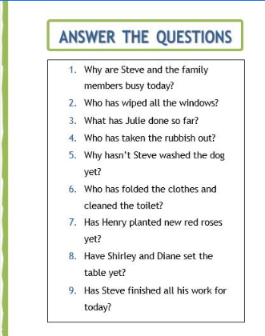

1. Because the were doing a loto f housework
2. Steven helped take out the trash
3. I hadn t washed it yet because thre was no shampoo left
4. Yes in the garden
5. Henry cleaned all the Windows
6. Julie vacuumed the floor did the laundry and made lunch fo rus.
7. No but they haven t loaded the dishwasher or set the Tablet yet
8. Steve hasn t done it yet
9. No Steve hasn t done his homework or Steven didn t finish his work.